SIMATS ENGINEERING

SAVEETHA INSTITUTE OF MEDICAL AND TECHNICAL SCIENCES

CHENNAI-602105

CSA0839 – PYTHON PROGRAMMING FOR CYBER SECURITY

Submitted By :S. Jaswanth Venkata Rahul

**Problem Statement:**

Write a program to find the sum of the first N natural numbers using the formula sum = n*(n+1)/2.

A)

n = int(input("Enter a positive integer N: "))

if n > 0:

total = n * (n + 1) // 2

print("The sum of the first", n, "natural numbers is:", total)

else:

print("Please enter a positive integer.")

**Output:**

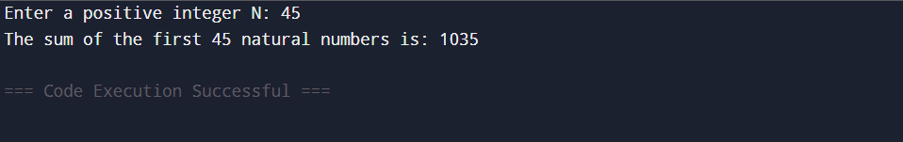

**Functional Requirements**

1. **Input:** Take a single integer input n.
2. **Process:** Calculate the sum using the formula sum = n * (n + 1) / 2.
3. **Output:** Return the result.

**Test Case:**

For integer N=5

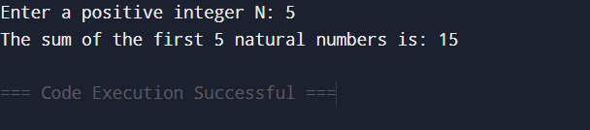

For integer N=1

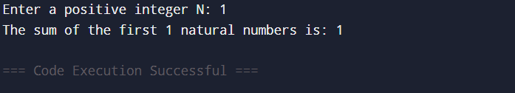

For integer N=10

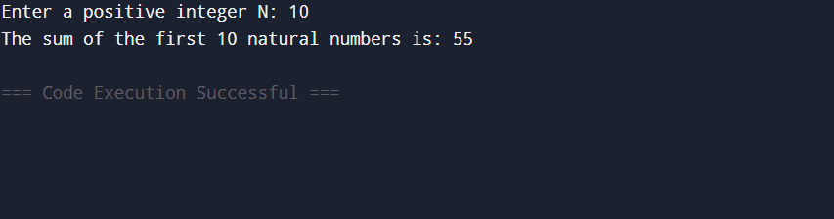

For integer N=0

